Axiom Requisition Copy Service
447 North Canal Road, Lansing, Michigan 48917
517.886.5099 – 877.886.5090 toll free – 517.886.4116 facsimile

Michael Lalikos, Esquire
Schneider & Lalikos
8 Essex Center Drive
Peabody, MA 01960

RE: SUBPOENA NOTICE
Mulcahy v. Uppington
Middlesex County Superior Court Division Civil Action No.: 08-04051

Dear Attorney Lalikos:

The requisite ten-day period has passed and I have received no notification from you that any objection has been raised. I will assume there is no objection to this request for information and will so notify the Keeper of Records for the following locations:

Town of Wakefield (Employment Records)

Attached please find a copy of the letter issued to the above-mentioned facilities.

Thank you for your attention to this matter.

Very truly yours,
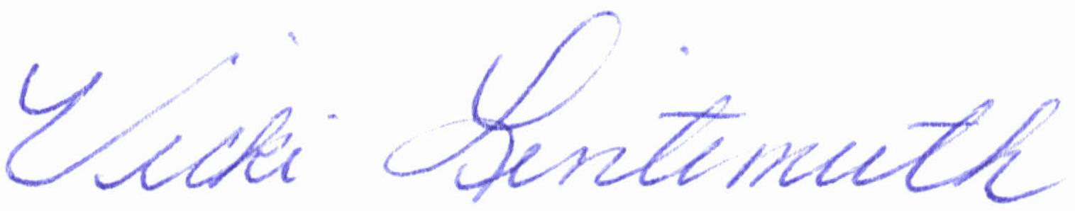

Vicki Lintemuth

Enclosure

Order No. 01-17101-007

